Donation Instructions:
Step 1. click the donate button (located at the bottom left corner.
.
Step 2. Select either pay by paypal or Pay by debit card.
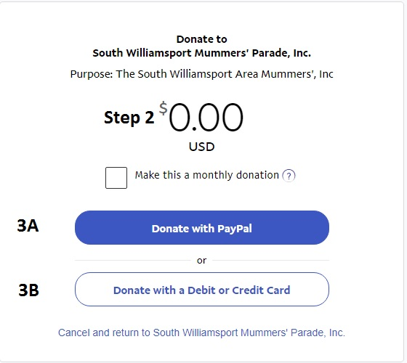
Step 3.
Step 3A: Login with PayPal account.
1. Login with Paypal Email account and password.
2.Set your amount you wish to donate.
3.Click Donate now.
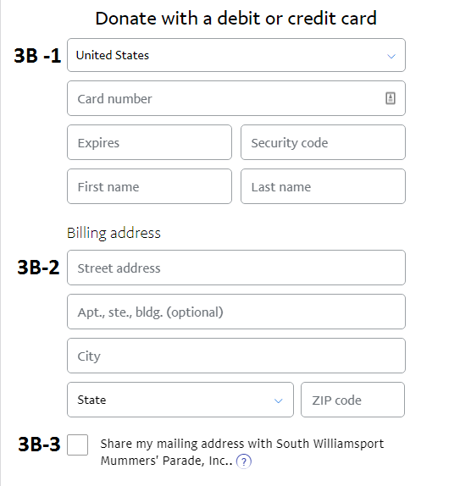
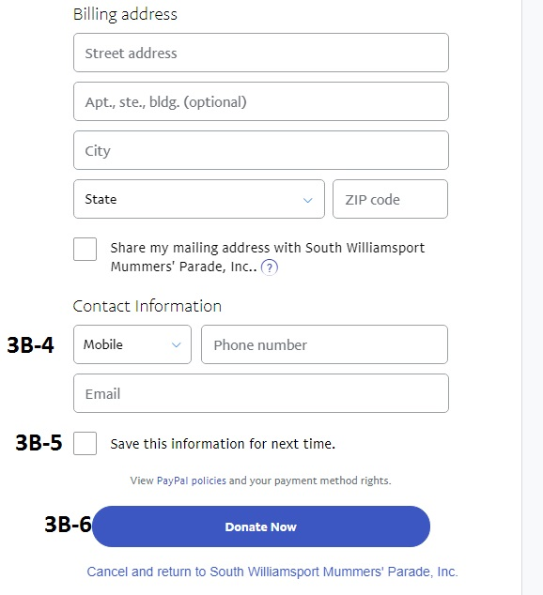
Step 3B: Debit Card (NOTE) if you do not have a paypal account it will ask for an email and password to complete the transaction.

1. Fill out your financial Information
2. Fill out Billing address Information
3. Check Share my information with South Williamsport Mummers Parade Inc.
4.Fill out contact information
5.Check Save this Information for next Time.
6.Click Donate now

